**FULL APPLICATION**

**TEMPLATE with instructions for project descriptions within the field of Strategic Vehicle Research and Innovation (FFI).**

The total number of pages in the project description should not exceed **15** (excluding summary, cover page, table of contents) in font size 11. If a longer project description is needed the applicant must contact the programme-management to obtain special dispensation.

The project description constitutes the primary basis for assessing and reviewing the application.

Applicants are recommended to read the FFI roadmap, call texts and instructions how to apply and report and other information that can be found on the FFI website, <https://ffisweden.se/en>, before writing their applications. All documents referred to in this template can be found on the website.

The applications that meet the formal requirements will be evaluated against the assessment criteria by an extern quality review group, who are appointed by Vinnova. The application is assessed in competition with other applications received. The review group adheres to professional secrecy as if they were under the employment of the agency.

*This page along with tips and information written in cursive format should be deleted before submitting your application.*

**Application within FFI <*Programme name*>**

**<Insert the title of your project here>**

Date:

Is it a reworked application that has previously been assessed by the FFI quality review group?

Yes  No

If yes, specify the reference number:

Describe shortly what is new or changed from your previous application

Enter the program's **focus area** or the equivalent to which the application is directed. Several answers in descending order can be given if the call text allows that.

The coordinator is responsible for submitting the application and who is then responsible for communication with and reporting within the programme.

# Summary

Your text here...

The summary should be no longer than half a page and specify:

* Background and objectives of the project
* The potential of the project in relation to the focus of the call
* Competitive intelligence and state-of-the art
* Feasibility and utilization, including the duration of the project, the total cost and funding applied for.
* Actors
  + Which partner is the main applicant (coordinator).
  + Other partners involved in the project.

Table of contents

Summary 3

Table of contents 4

Background and goals for the project 1

Potential 1

State-of-the-art 2

Feasibility 3

Project contents 3

Scheduling 3

Project financing 4

Utilization 4

Actors 4

Equality 5

References 5

Right-click the table of contents to find the function for updating contents and page numbers.

You have three levels of headings at your disposal (Heading 1, 2 and 3).

# 

# Background and goals for the project

Your text here...

* Provide a background for the project and clearly describe what/which problems or needs the project aims to address and the scope of the problems or needs, describe hypotheses/research issues. If possible, specify concrete and measurable objectives for the project (for example, x % reduction in energy consumption or reduction in fatal road accidents).
* Describe the projects innovation level within the relevant field of application, for example that new knowledge is produced or that current knowledge is applied in new contexts

# Potential

Your text here…

*Describe the following:*

* *The project's potential to contribute to FFI's overall goals through relevant issues and level of innovation.*
* *The project's potential to contribute to the sub-programme's focus areas and the focus of the call.*
* *The potential of the project to develop new innovative solutions, rather than incremental improvements to existing solutions.*

# State-of-the-art

Your text here...

Give a description of both how project stems from solid external monitoring and how it relates to the current international state of the art of the research/technology field.

A list of references is to be placed last in the document.

If the project is a continuation of a previous project, clearly state what results have been achieved and how they are used and influence the continuation project. If there is a final report available, it can be submitted as an attachment. Also state the following:

|  |
| --- |
| Project number: |
| Title: |
| Programme affiliation: |
| Decision-making agency: |
| Summary of results and conclusions: |

If not, delete this table.

# Feasibility

## Project contents

Your text here...

Describe the content and setup of the project. The description should embrace different work packages content, role and responsibility of leaders and other participants and defined deliverables/milestones. Describe how the work packages will be evaluated against the set goals.

Also describe working and research methodology (scientific hypothesis and methods where it is relevant).

Then give a more detailed description of the contents of each respective activity/work package and specify who does what. Feel free to use the format below:

|  |  |
| --- | --- |
| **<Work Package (WP) no X>** | **<Name of activity/work package (WP)>** |
| Leader (role and responsibility) |  |
| Other participants (roles and responsibilities) |  |
| Description of contents |  |
| Method/approach (when relevant) |  |
| Delivery and evaluation |  |

## Scheduling

Your text here...

Specify the project time schedule, start and end dates, showing important activities/work packages and milestones, as well as when different deliveries can be expected. A simple Gantt diagram and a table of milestones, as shown in the example below, may be helpful.

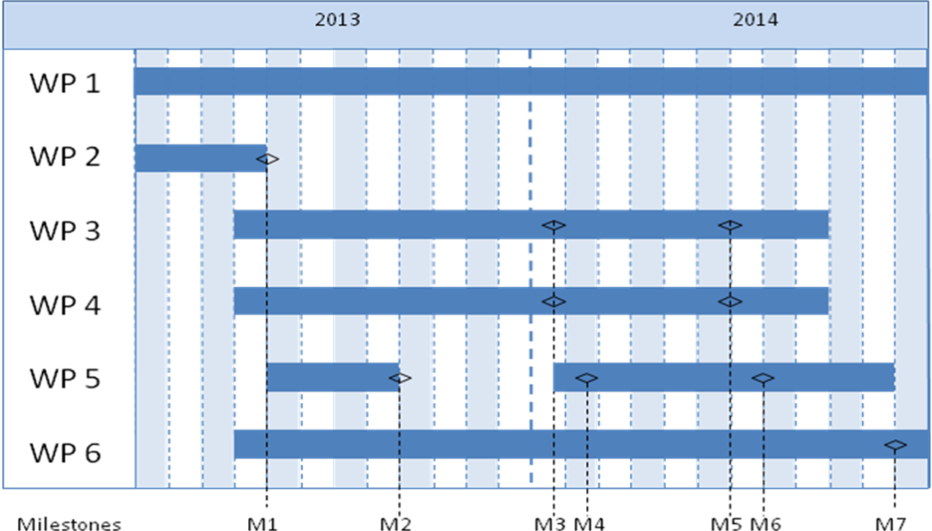

|  |  |  |
| --- | --- | --- |
| Milestone | Description | Date |
| M1 |  |  |
| M2 |  |  |
| M3 |  |  |
| Mxx |  |  |

## Project financing

Your text here...

*The project financing per work package should be presented in the table below.*

|  |  |  |  |  |  |  |  |
| --- | --- | --- | --- | --- | --- | --- | --- |
|  | | Budget per participating party | | | | | Total budget/WP |
|  | | <Party 1> | | <Party 2> | | <Party x> |  |
| <WP1> | |  | |  | |  |  |
| <WP2> | |  | |  | |  |  |
| <WPx> | |  | |  | |  |  |
| TOTAL budget per part |  | |  | |  | |  |

*Personnel costs and wages for universities could be based on full actual costs where indirect costs must be presented separately. The industry and others may have indirect costs of a maximum of 30% of wage costs. These must be reported separately.*

*The table below can be used to specify the type of costs arising in the project.*

|  |  |
| --- | --- |
| Cost specification | Description |
| Equipment, facilities |  |
| Consultancy costs, licenses |  |
| Other direct costs incl. travelling costs |  |
| Other costs |  |

## Utilization

Your text here...

Describe how the project aims to realise the potential of spreading/utilizing the results

# Actors

Your text here….

Describe how the project management will be organized. Also describe eventual steering- and reference groups.

*CV (a template is available at* [*https://ffisweden.se/en*](https://ffisweden.se/en)*) needs to be submitted for the project manager, work package leaders and other key personnel so that the project participants competence and abilities can be assessed.*

*Other relevant information about the parties can also be submitted here.*

*If subcontractors are to be procured (for example consultants) this must be specified along with the purpose and extent of their involvement in the project.*

# Equality

Your text here….

*Many problems, results and solutions can seem to be gender neutral, but they still affect women and men differently. How do you intend to take this into account in this project and how can it affect the project's effects?*

* *Describe how the project team is composed regarding gender distribution, but also the distribution of power and influence between men and women.*
* *Describe how equality aspects have been integrated in the project.*
* *Describe equality aspects (gender and gender perspective) that can be important to take into consideration in relation to the projects field of study, solutions, and effects.*

# References

*List your references (scientific publications, monographs, conference articles etc.) here. Be restrictive when referring to websites as these have not been “quality reviewed” in the same ways as a publication and the addresses have a tendency to quickly become obsolete.*

The “References” section can be omitted if it is not needed.